**Korytko Alexander**

Task 7

# Prerequisites Task

## Passwords Index

|  |  |  |
| --- | --- | --- |
| Password Group | Login Name | Password |
| Operation System | root | “rootadmin” |
|  | oracle | “oracleadmin” |
|  |  |  |
| Oracle System | sys | “sysadmin” |
|  | system | “sysadmin” |
|  |  |  |
| Oracle Users | All DB users | “%PWD%” |
|  |  |  |
|  |  |  |

## Folder Paths Index

|  |  |  |
| --- | --- | --- |
| Path Group | Path Description | Path |
| Operation System | Oracle RDBMS – BIN | /oracle/app/oracle |
|  | Oracle Inventory | /oracle/app/oraInventory |
|  | Oracle Database Storage | /oracle/oradata |
|  | Oracle Install Directory | /oracle/install |
| Oracle | ORACLE_BASE | /oracle/app/oracle |
|  | ORACLE_HOME | $ORACLE_BASE/product/11.2 |
|  |  |  |
| FTP | ftp Incoming Folder | **/ftp/incoming** |
|  |  |  |
|  |  |  |

# Create and populate Dimension of TIME DW – Layer

**Notes:**

To Populate Time dims use External Resources:

|  |  |
| --- | --- |
| File Name | Path |
| Calendars.sql | … \Topic 07 - Dimension and Facts Basics\LabScripts\ |

## Task 01: CREATE DW.T_DAYS

**The Main Task** is to create Physical diagram and Objects on DW layer:

**Task Results:**

Create document, which contained next chapters:

* + Physical diagram store on GIT
  + Links to Scripts on GIT

## Task 02: CREATE DW.T_WEEKS

**The Main Task** is to create Physical diagram and Objects on DW layer:

**Task Results:**

Create document, which contained next chapters:

* + Physical diagram store on GIT
  + Links to Scripts on GIT

## Task 03: CREATE DW.T_MONTHS

**The Main Task** is to create Physical diagram and Objects on DW layer:

**Task Results:**

Create document, which contained next chapters:

* + Physical diagram store on GIT
  + Links to Scripts on GIT

## Task 04: CREATE DW.T_QUARTERS

**The Main Task** is to create Physical diagram and Objects on DW layer:

**Task Results:**

Create document, which contained next chapters:

* + Physical diagram store on GIT
  + Links to Scripts on GIT

## Task 05: CREATE DW.T_YEARS

**The Main Task** is to create Physical diagram and Objects on DW layer:

**Task Results:**

Create document, which contained next chapters:

* + Physical diagram store on GIT
  + Links to Scripts on GIT

**RESULTS:**

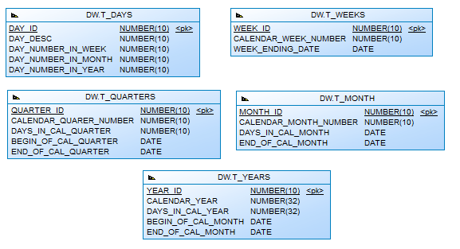

# OLAP – Business analyses task

## Task 06 – Solution concept – Add: Chapter Dimensions Types

**The Main Task** is to create summary table to describe all future STAR Dimensions:

Next points are mandatory:

* Start scheme must use no less one of SCD type 2 Dimension
* Start scheme must use prepared dimensions: DIM_TIME, DIM_GEO_LOCATIONS
* Start scheme must use one of period dimensions: DIM_GEN_PERIODS

**Task Results:** 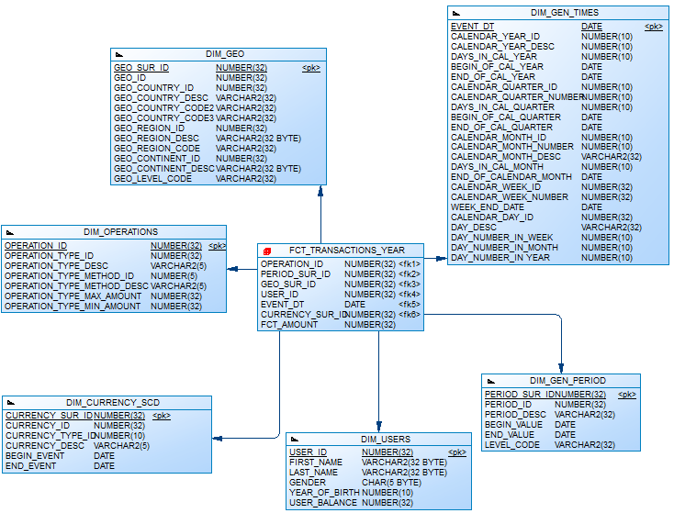

Create document, which contained next chapters:

* + Chapter: Dimensions Types Description

|  |  |  |  |  |
| --- | --- | --- | --- | --- |
| Name | Type | Size | DW – Merged Dimensions | Descriptions |
| DIM_GEN_TIMES | SCD1 | BIG | DW.T_DAYS, DW.T_WEEKS, DW.T_MONTHS, DW.T_QUARTERS,  DW.T_YEARS | Dimension table with list of time parameters for analytics |
| DIM_USERS | SCD1 | BIG | DW.T_USERS  DW.T_GENDER  DW.T_YEAR_OF_BIRTH | Dimension table with details information about of users |
| DIM_GEO | SCD2 | SMALL | DW.T_COUNTRIES  DW.T_CNTR_GROUPS  DW.T_CNTR_SUB_GROUPS  DW.LC_CNTR_GROUPS  DW.T_GEO_TYPES  DW.T_GEO_SYSTEMS  DW.LC_GEO_SYSTEMS  DW.T_GEO_PARTS  DW.T_GEO_REGIONS  DW.T_GEO_OBJECTS  DW.T_CNTR_GROUP_SYSTEMS  DW.LC_CNTR_GROUP_SYSTEMS  DW.LC_CNTR_SUB_GROUPS  DW.LC_ GEO_PARTS  DW.LC_COUNTRIES  DW.LC_ GEO_REGIONS | Dimension table with full information about all countries, regions, subregions, economic types and some other classifications etc. |
| DIM_GEN_PERIOD | SCD1 | SMALL | DW.T_PERIOD_DESC  DW.T_PER_START  DW.T_PER_END  DW.T_LEVEL_CODE | Dimension table with information how to group our facts |
| DIM_CURRENCY_SCD | SCD2 | SMALL | DW.T_CURRENCY  DW.T_CURRENCY_TYPES | SCD2 Type dimension with list of all currencies and types of them (convertible or not) |
| DIM_OPERATIONS | SCD1 | SMALL | DW.T_OPERATIONS_TYPES  DW.T_OPERATIONS_METHODS | Dimension table with details information about operations (DEPOSIT/WITHDRAWAL) and used methods for them (Credit Cards, Check, Webmoney and etc) |

## Task 07 – Solution concept – Add: Chapter Dimensions Hierarchies

**The Main Task** is to create summary table to describe all future STAR Dimensions Hierarchies:

Next points are mandatory:

* Start scheme must use no less one of SCD type 2 Dimension
* Start scheme must use prepared dimensions: DIM_TIME, DIM_GEO_LOCATIONS
* Start scheme must use one of period dimensions: DIM_GEN_PERIODS

**Task Results:**

Create document, which contained next chapters:

* + Chapter: Dimensions Hierarchies

**DIM_GEN_TIME:**

**Hierarchy DAY-WEEK-MONTH-YEAR**

|  |  |  |  |
| --- | --- | --- | --- |
| Name | LEVEL_CODE | LEVEL_DESC | LEVEL_NATURAL_KEY |
| DAYs | DAY | Store day at the calendar | DAY_ID |
| WEEKs | WEEK | Store weeks at the calendar year | WEEK_ID |
| MONTHs | MONTH | Store months at the calendar year | MONTH_ID |
| YEARs | YEAR | Store years at the calendar year | YEAR_ID |

**Hierarchy DAY--MONTH- QUARTER -YEAR**

|  |  |  |  |
| --- | --- | --- | --- |
| Name | LEVEL_CODE | LEVEL_DESC | LEVEL_NATURAL_KEY |
| DAYs | DAY | Store day at the calendar year | DAY_ID |
| MONTHSs | MONTH | Store months at the calendar year | WEEK_ID |
| QUARTERs | QUARTER | Store quarters at the calendar year | QUARTER_ID |
| YEARs | YEAR | Store years at the calendar year | YEAR_ID |

**DIM_CURRENCY:**

|  |  |  |  |
| --- | --- | --- | --- |
| Name | LEVEL_CODE | LEVEL_DESC | LEVEL_NATURAL_KEY |
| CURRENCY_TYPE | CURRENCY_TYPE | Describe currency type (Convertible or not) | CURRENCY_TYPE_ID |

**DIM_GEO LOCATIONS:**

**Hierarchy COUNTRY –REGION -- CONTINETS**

|  |  |  |  |
| --- | --- | --- | --- |
| Name | LEVEL_CODE | LEVEL_DESC | LEVEL_NATURAL_KEY |
| COUNTRIES | COUNTRY_NAME | All countries in regions | GEO_COUNTRY_ID |
| REGIONS | COUNTRY_REGION | All regions on continents | GEO_COUNTRY_REGION_ID |
| CONTINENTS | COUNTRY_CONTINENT | All continents in the world. | GEO_COUNTRY_ CONTINENT _ID |

**DIM_OPERATION:**

**Hierarchy** OPERATION_TYPE -- OPERATION_METHODS

|  |  |  |  |
| --- | --- | --- | --- |
| Name | LEVEL_CODE | LEVEL_DESC | LEVEL_NATURAL_KEY |
| OPERATION_TYPE | OPERATION_TYPE | Deposit/Withdrawal | OPERATION_TYPE_ID |
| OPERATION_METHODS | OPERATION_METHODS | Credit Cards, Bank transfer, Check, Webmoney | OPERATION_METHOD_TYPE_ID |

## Task 08 – Solution concept – Add: Chapter Facts Aggregations

**The Main Task** is to create summary table to describe all future STAR Fact Table Aggregations:

Next points are mandatory:

* Create more than one measurement
  + Summarize aggregation
  + Additional task: Not Additive measurement

**Task Results:**

Create document, which contained next chapters:

* + Chapter: Facts Aggregations

|  |  |  |  |  |
| --- | --- | --- | --- | --- |
| Name | Code | Table Name | Additive | Descriptions |
| Counts total amount of transaction | FCT_AMOUNT | FCT_AMOUNT | + | Calculate distinct values of Transaction at the EVENT_DT period. |